**FPT ACADEMY INTERNATIONAL**



## FPT – APTECH COMPUTER EDUCATION

**MOONLIGHT EVENTS**

|  |  |  |  |
| --- | --- | --- | --- |
| **Center Name** | | FPT – Aptech – HCM  Address: 391A Nam Ky Khoi Nghia, District 3, Ho Chi Minh City | |
| **Instructor** |  | Ms. Le Mong Thuy |  |
| **Class** |  | T1.2210.M0 |  |
| **Group** |  | 6 |  |
| **Group members** | | **Name** | **Student ID** |
|  |  | Ngo Nguyen Duy Khang | Student1429108 |
|  |  | Tran Anh Tien | Student1429100 |
|  |  | Trinh Thi Tuong Vy | Student1429092 |
| **Duration** | Start date | 01th Feb 2023 |  |
| End date | 03th Mar 2023 |  |

**This is to certify that**

**Mr.,Ms.:**

Ngo Nguyen Duy Khang

Tran Anh Tien

Trinh Thi Tuong Vy

**Has successfully designed & developed**

eProject: MoonLight Events website

**Submitted by:**

Ngo Nguyen Duy Khang

**Date of issue: 01-Feb-2023**

**Authorized Signature:**

**TABLE OF CONTENTS**

****FPT – APTECH COMPUTER EDUCATION 1****

****TABLE OF CONTENTS**** ****2****

****ACKNOWLEGMENT**** ****3****

****SYNOSIS**** ****3****

****PROBLEM DEFINITION**** ****3****

****CUSTOMER'S REQUIREMENTS SPECIFICATIONS (CRS) 4****

****Business/Project Objective**** ****4****

****Hardware/ Software Requirements**** ****5****

****SCOPE OF THE WORK (IN BRIEF) 7****

****Architecture and design of the system 8****

****Diagram of the website 9****

****TASK SHEET REVIEW 1 10****

****SITE MAP 11****

****MOCK OF THE WEBSITE 1********2****

***1. Homepage 1******2***

***2. News 1******3***

***3. Products 1******4***

***4. Gallery 1******5***

***5. About Us 1******6***

***6. Contact Us 1******7***

***7. Account 1******8***

****TASK SHEET REVIEW 2 19****

WEBSITE DESCRIPTION ****20****

RESPONSIVE****31****

[****JAVASCRIPT DESCRIPTION****](#Javascript) ****32****

****TASK SHEET REVIEW 3**** ****35****

# ACKNOWLEGMENT

On behalf of team members. I would like to thank everyone who supported my team to successfully complete this eProject report. Especially, our teacher, she has supported us a lot since we started studying at FPT Aptect. With this eProject, she guided us very meticulously, enthusiastically and strictly. With her guidance, we were able to successfully complete this project. Besides, I also want to thank all the team members, each of whom worked hard to complete the eProject in earnest during the month of working together. Finally, our group would like to say thank you to my classmates and family for sharing and creating for the group the best environment to focus on the project, motivating the members to achieve their goals.

# SYNOSIS

# The goal of the eProject is that we need to create a website that meets all the requirements of the client, Moonlight Events. MOONLIGHT EVENTS organizes festivals around the world, in collaboration with municipalities, and local city associations, where we have been hosting festivals for many years. Festivals exist to strengthen young people's understanding of other cultures, to develop a tolerant attitude of young people towards cultural differences, to gain respect for ethnic characteristics and unique forms of artistic realization. Our main goal is to spread the information about local festivals and discover the talents, to support their creativity. The festival is held to encourage academic, professional and cultural exchange between groups. Customer satisfaction is always the top goal of Moonlight Events.

# PROBLEM DEFINITION

The portal will be designed as a Single-Page-Application and responsive Website with a set of pages and menus that represent choice of activities to be performed. The pages, menus, and other visual elements must be designed in a visually appealing manner with attractive fonts, colors, and animations.

All of these should also be laid out in a responsive manner

The Web site is to be created based on the following requirements.

1) The Top of the Page should be presented with a suitable logo and a banner with images of some festivals.

2) Categorisation of important festivals from various countries should be provided.

3) Categorisation of festivals religion wise should be provided with brief details.

4) Clicking on any festival should open a pop-up window with various images, details and historic importance should be provided.

5) Filters based on Religion, Month can be added for viewing different images.

6) Gallery with various images of festivals should be provided.

7) Feedback must be allowed to enter by the viewer

8) Site map, Gallery, about us, FAQ link, Contact us link must be added.

9) About Us and Contact Us: This menu option should display Email id, address, and contact number.

10) The complete historic reason and its description must be allowed to get download as pdf or doc file.

11) Color combination must be uniform throughout the project.

12) Navigation must be smooth.

Over and above this, the portal should implement the following functionalities:

• Display a continuous scrolling ticker at the bottom of the page with current date, time, and location (hint: Use geolocation features of HTML5).

• Display a visitor count at the top right corner of the page beside a logo image.

• The menu options should change color on hover and also after clicking.

• Fade in and fade out options can be used for the menus.

# CUSTOMER'S REQUIREMENTS SPECIFICATIONS (CRS)

**Client: Moonlight Events**

### Business/Project Objective:

We need a website that provides information about various festivals which are celebrated across the world. The site should provide the festival data in proper categorization from different countries along with their details.

You are supposed to create a Single-Page-Application and responsive Website for them with the below mentioned requirement specifications.

The website is to be developed for the Windows Platform using HTML5, JSON, Angular JS, JavaScript and Geolocation. The site should work well in all leading browsers including Chrome, IE, Firefox etc.

**Input to the system:**

- Search results based on COUNTRY, RELIGION, SEASON and other suggestions.

- Register members on website.

- Feedback about the quality of results.

**Output from the system:**

- Perform search based on: COUNTRY, RELIGION, SEASON and other suggestions.

- Display results for each type of information according to the search content.

- Display a button for customers to download search results content.

- The website may provide a brief introduction/history about us in the About page.

- The location of the shop under Contact-Us page.

- Displays FAQ and allows users to email directly to the company.

**Process**:

* + - * Validate data input from users.

**Expected delivery date:** 03-March-2023.

**List of deliverables:**

- Document Word, PDF.

- User Guide.

- Source code.

### Hardware/ Software Requirements:

* **For developer**

**Hardware**

* Intel Core i3/i5 Processor or higher
* 8 GB RAM or above
* Color SVGA
* 500 GB Hard Disk space
* Mouse
* Keyboard

**Software**

Technologies to be used:

* Frontend: HTML5, CSS, Bootstrap, JavaScript, jQuery, AngularJS, XML
* Data Store: JSON files or TXT files

Other Requirements:

* Operating Portal: Windows
* Browsers: Edge, Chrome, Mozilla Firefox, Safari
* **For web users**

**Hardware**

* Intel Core i3/i5 Processor or higher
* 8 GB RAM or above
* Color SVGA
* 500 GB Hard Disk space
* Mouse
* Keyboard

**Software**

Technologies to be used:

* Frontend: HTML5, CSS, Bootstrap, JavaScript, jQuery, AngularJS, XML
* Data Store: JSON files or TXT files

Other Requirements:

* Operating Portal: Windows
* Browsers: Edge, Chrome, Mozilla Firefox, Safari

# SCOPE OF THE WORK (IN BRIEF)

After a long and detailed discussion, our group has decided to create a website contain the following webpages:

1. Introduction page: Allows users to watch short videos and stimulate users to delve into the wed.
2. Home page: There is a search bar to search for the results that users want. There is a place for users to FAQ.
3. Countries: Show some major countries in the world
4. Religion: Shows the major religions of the world
5. About Us: Display information about us, customer reviews.
6. Contact us: Display company address, Map and allow customers to request any information they want to Moonlight Events.
7. Sign In/ Sign Up: Allows users to register or log in to the website.

# ARCHITECTURE AND DESIGN OF THE SYSTEM

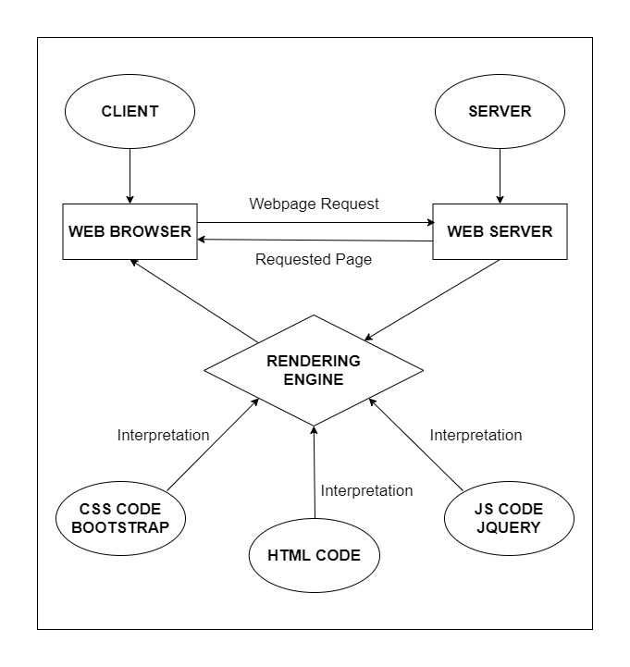

# 

# DIAGRAM OF THE WEBSITE

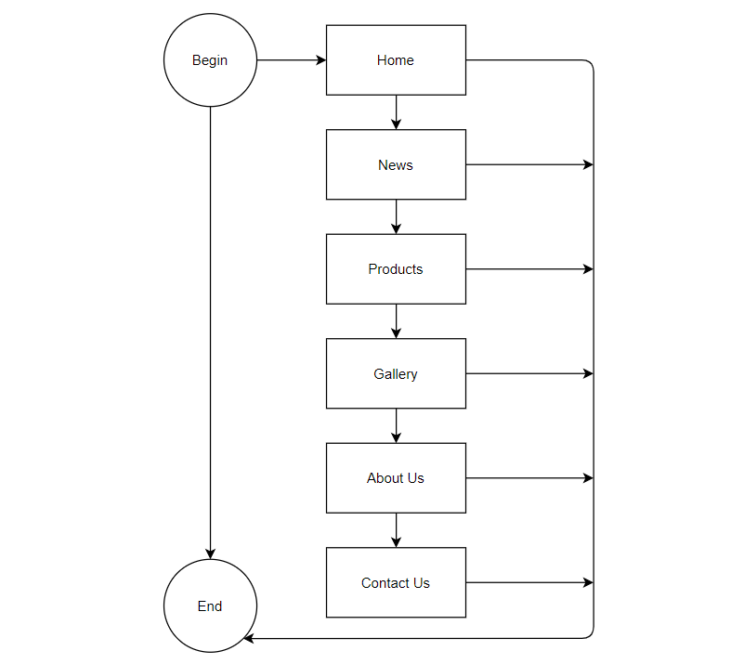



# TASK SHEET REVIEW 1

|  |  |  |  |  |  |  |  |
| --- | --- | --- | --- | --- | --- | --- | --- |
| **Project Ref. No.:**  **eP/Advertisement Portal Management**  **System/01** | | **Project Title:** | **Activity Plan Prepared By:** | **Date of Preparation of Activity Plan:** | | | |
| **Sr.**  **No.** | **Task** | **Actual**  **Start**  **Date** | **Actual Days** | **Team**  **Mate Names** | **Status** |
| 1 | Problem Statement | MOONLIGHT  EVENTS | Khang | 02-Feb-23 | 1 | Khang | Completed |
| 2 | Analysis of Moonlight Events requirements about the website | 02-Feb-23 | 1 | Khang | Completed |
| 3 | The scope of the work (in brief) | 02-Feb-23 | 1 | Tien | Completed |
| 4 | Architecture and design of the system | 02-Feb-23 | 1 | Tien | Completed |
| 5 | Diagram of the website | 02-Feb-23 | 1 | Vy | Completed |
| 6 | Task Sheet | 02-Feb-23 | 1 | Vy | Completed |

|  |  |
| --- | --- |
| **Date:** | |
| Signature of Instructor:  **Ms. Le Mong Thuy** | Signature of Team Leader:  **Ngo Nguyen Duy Khang** |

# SITE MAP

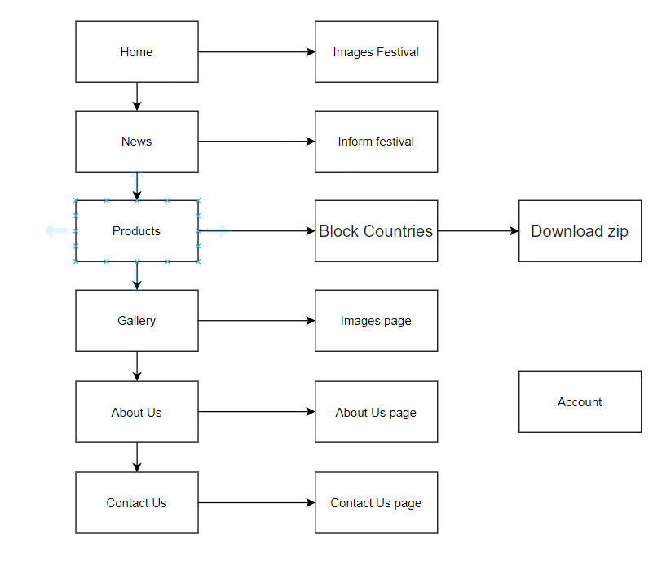

# MOCK OF THE WEB

1. **Homepage**

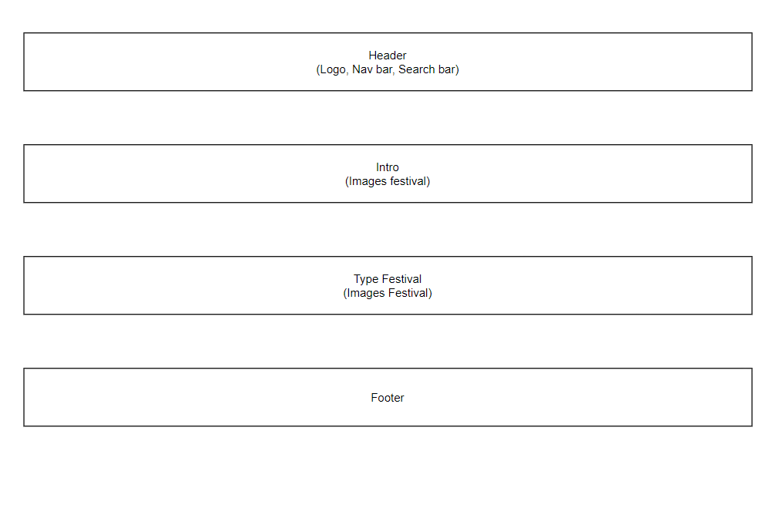

1. **News**

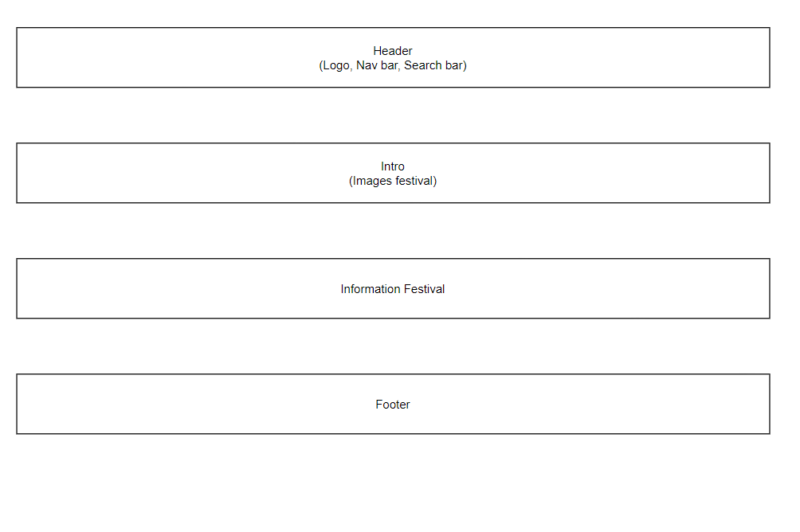

1. **Products**

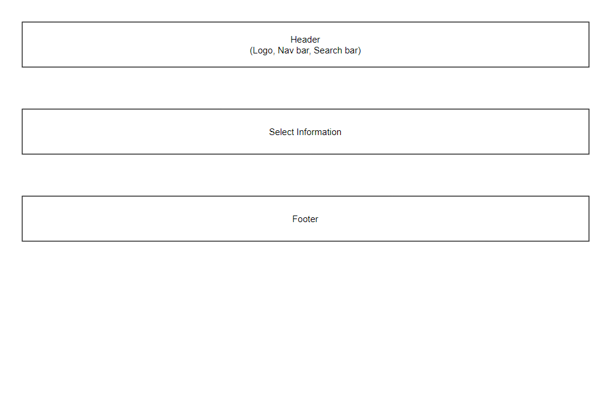

1. **Gallery**

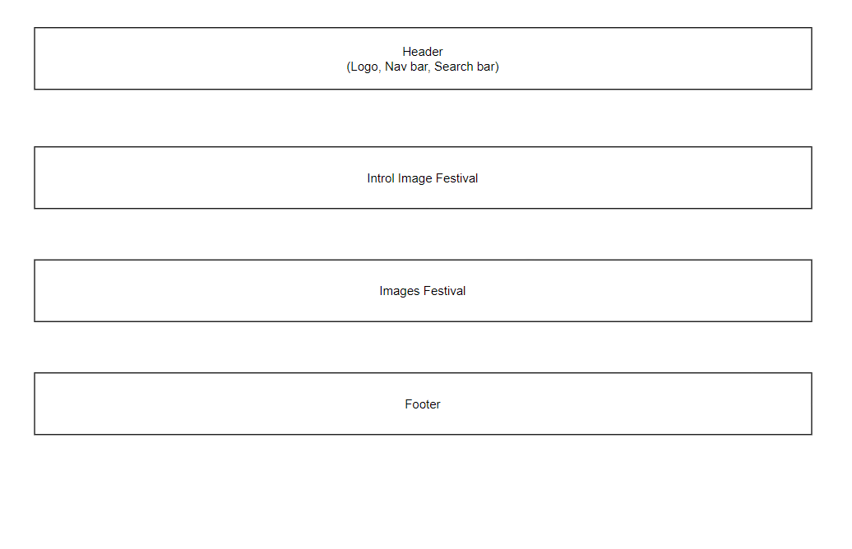

1. **About Us**

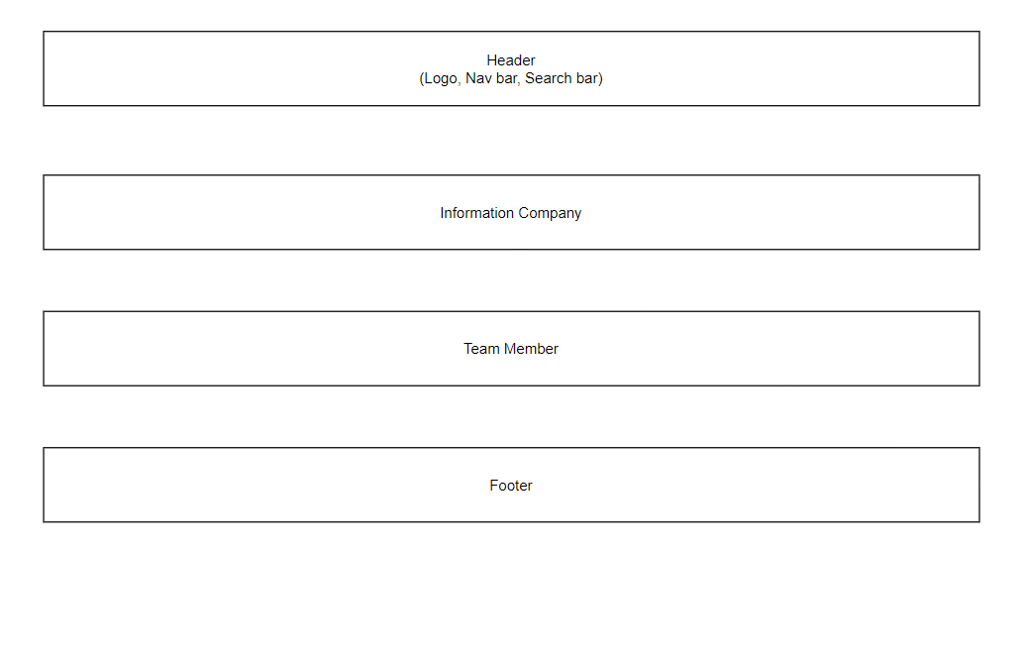

1. **Contact Us**

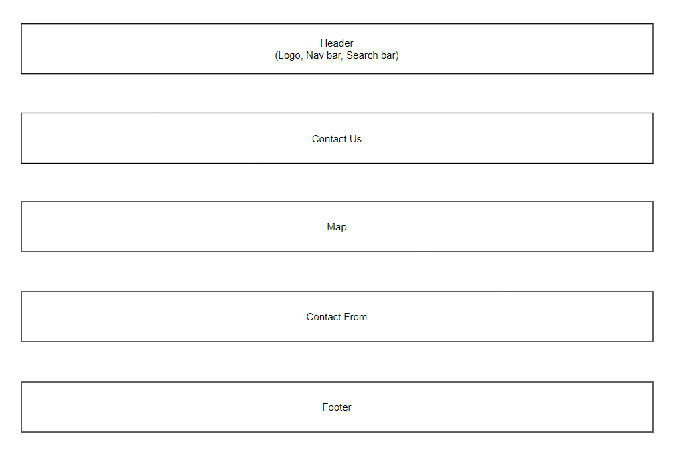

1. **Account**

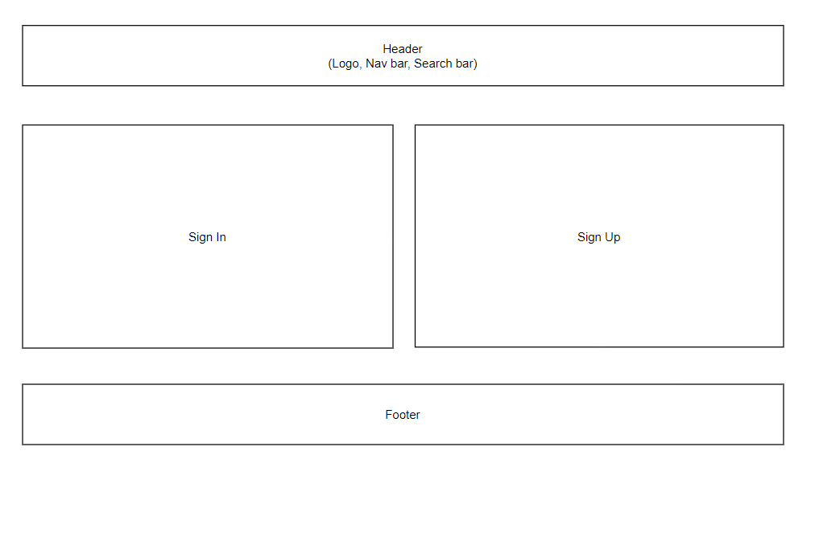

# TASK SHEET REVIEW 2

|  |  |  |  |  |  |  |  |
| --- | --- | --- | --- | --- | --- | --- | --- |
| **Project Ref. No.:**  **eP/Advertisement Portal Management**  **System/01** | | **Project Title:** | **Activity Plan Prepared By:** | **Date of Preparation of Activity Plan:** | | | |
| **Sr.**  **No.** | **Task** | **Actual**  **Start**  **Date** | **Actual Days** | **Team**  **Mate Names** | **Status** |
| 1 | Site Map | Moonlight  Events | Khang | 06- Feb -23 | 1 | Khang | Completed |
| 2 | Mock of the website | 06- Feb -23 | 2 | Tiến | Completed |
| 3 | Task sheet | 06- Feb -23 | 2 | Vy | Completed |

|  |  |
| --- | --- |
| **Date:** | |
| Signature of Instructor:  **Ms. Le Mong Thuy** | Signature of Team Leader:  **Ngo Nguyen Duy Khang** |

# WEBSITE DESCRIPTION

1. **Homepage**
2. Screen shot

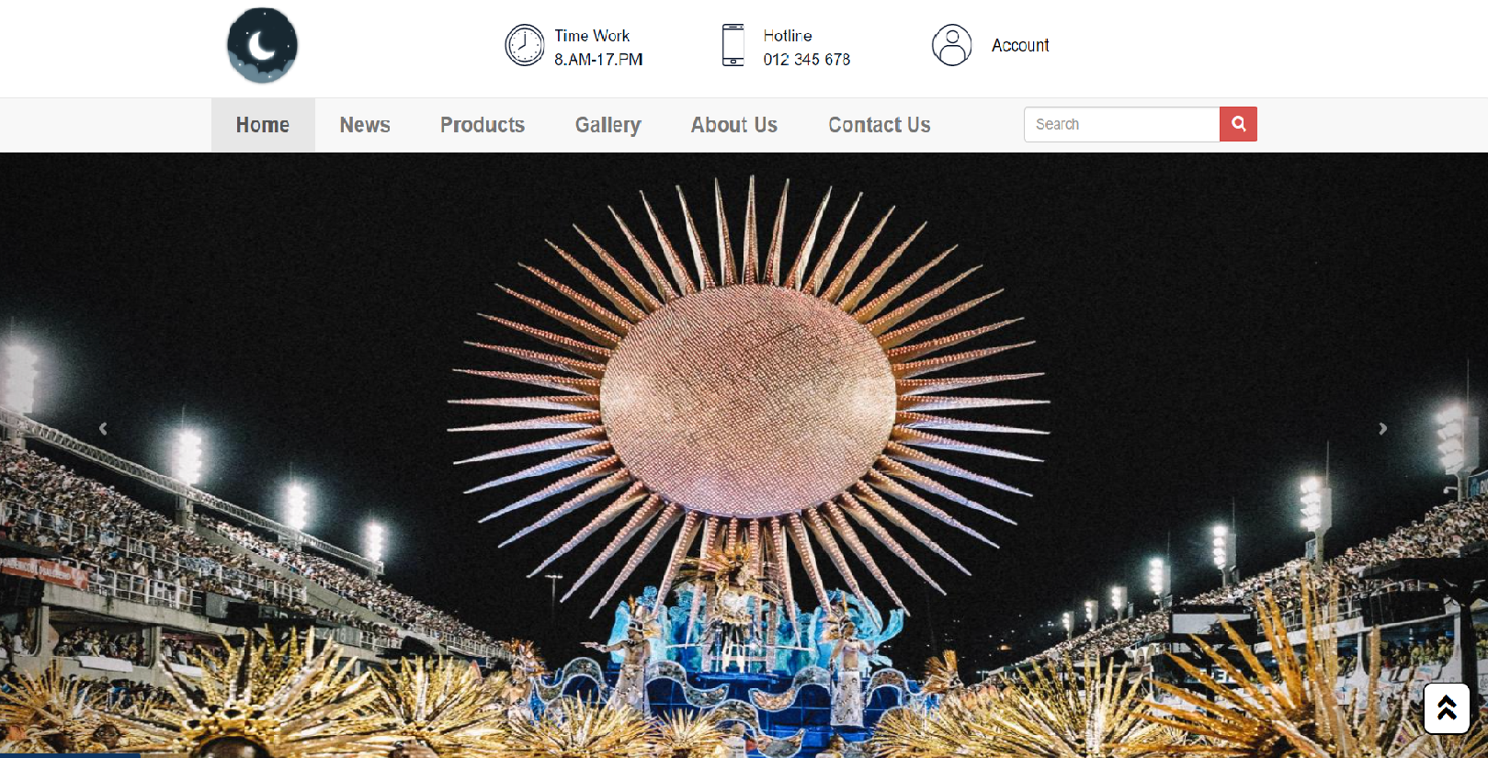

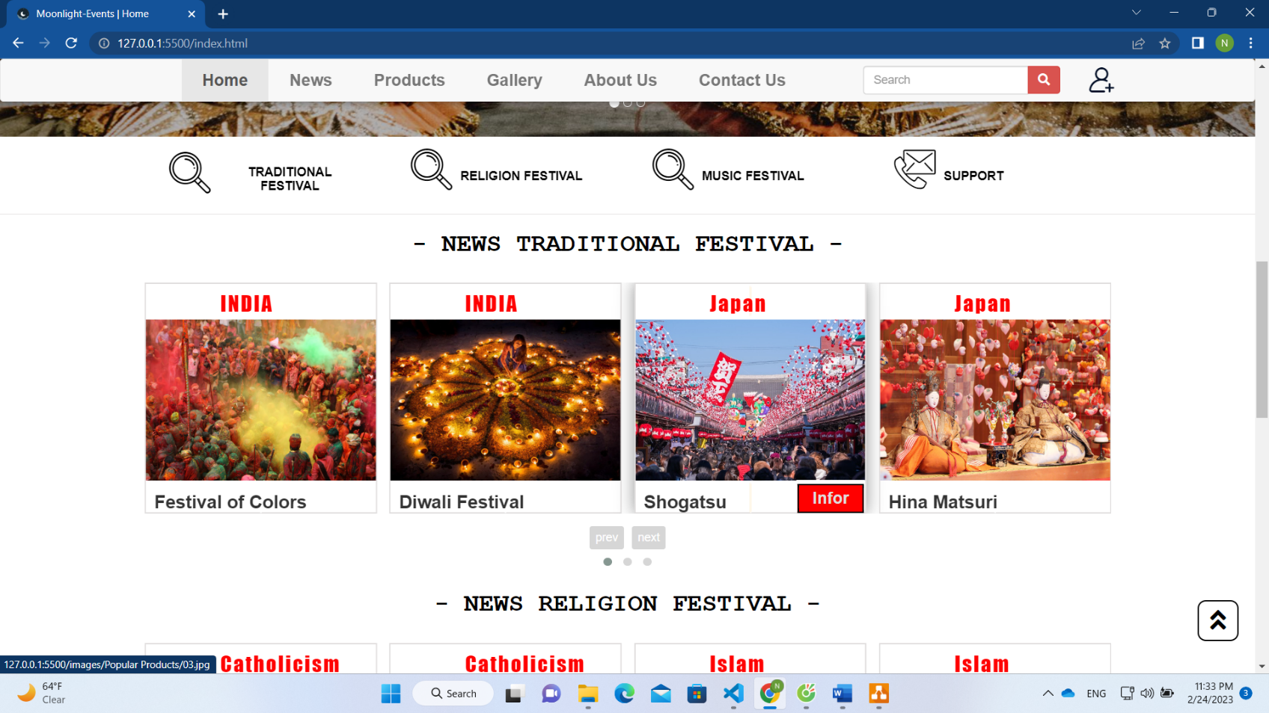

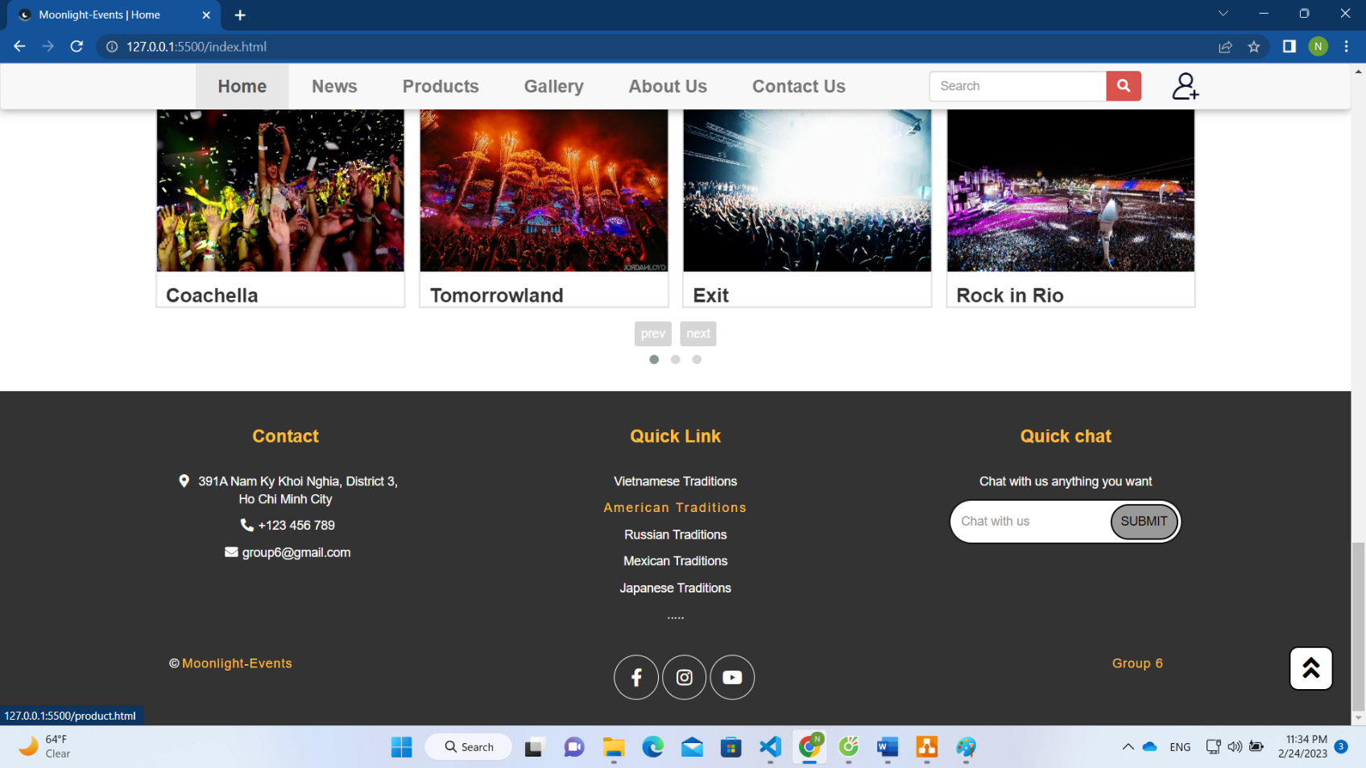

1. **News**
2. Screen shots

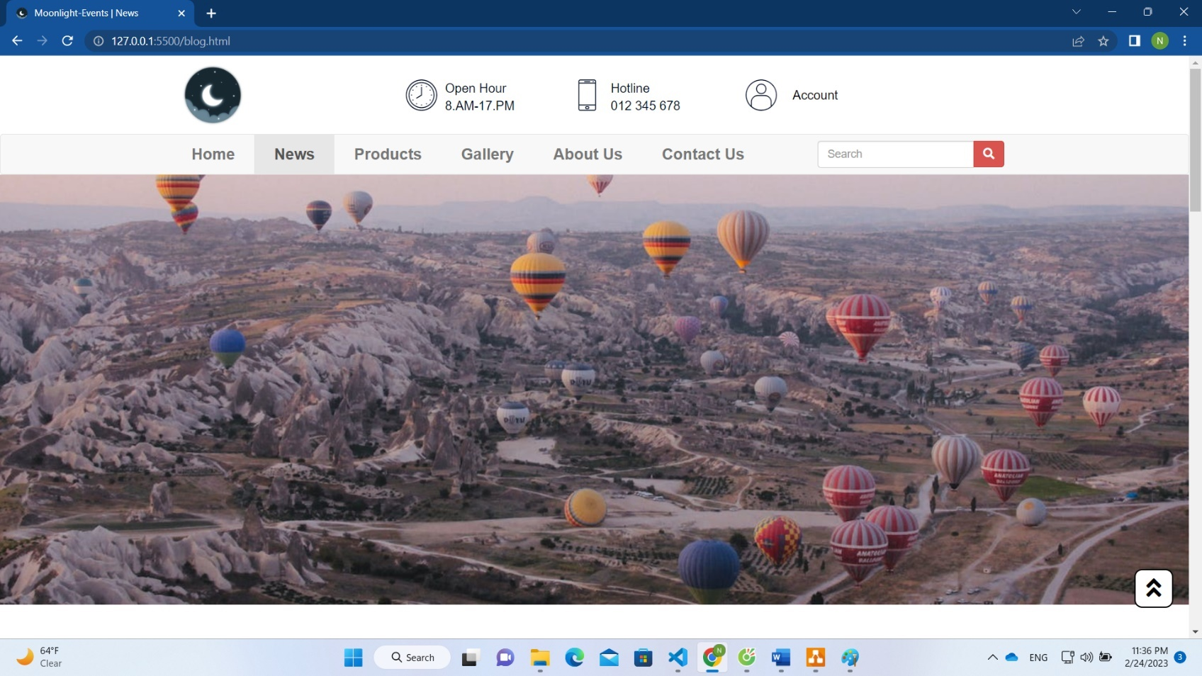

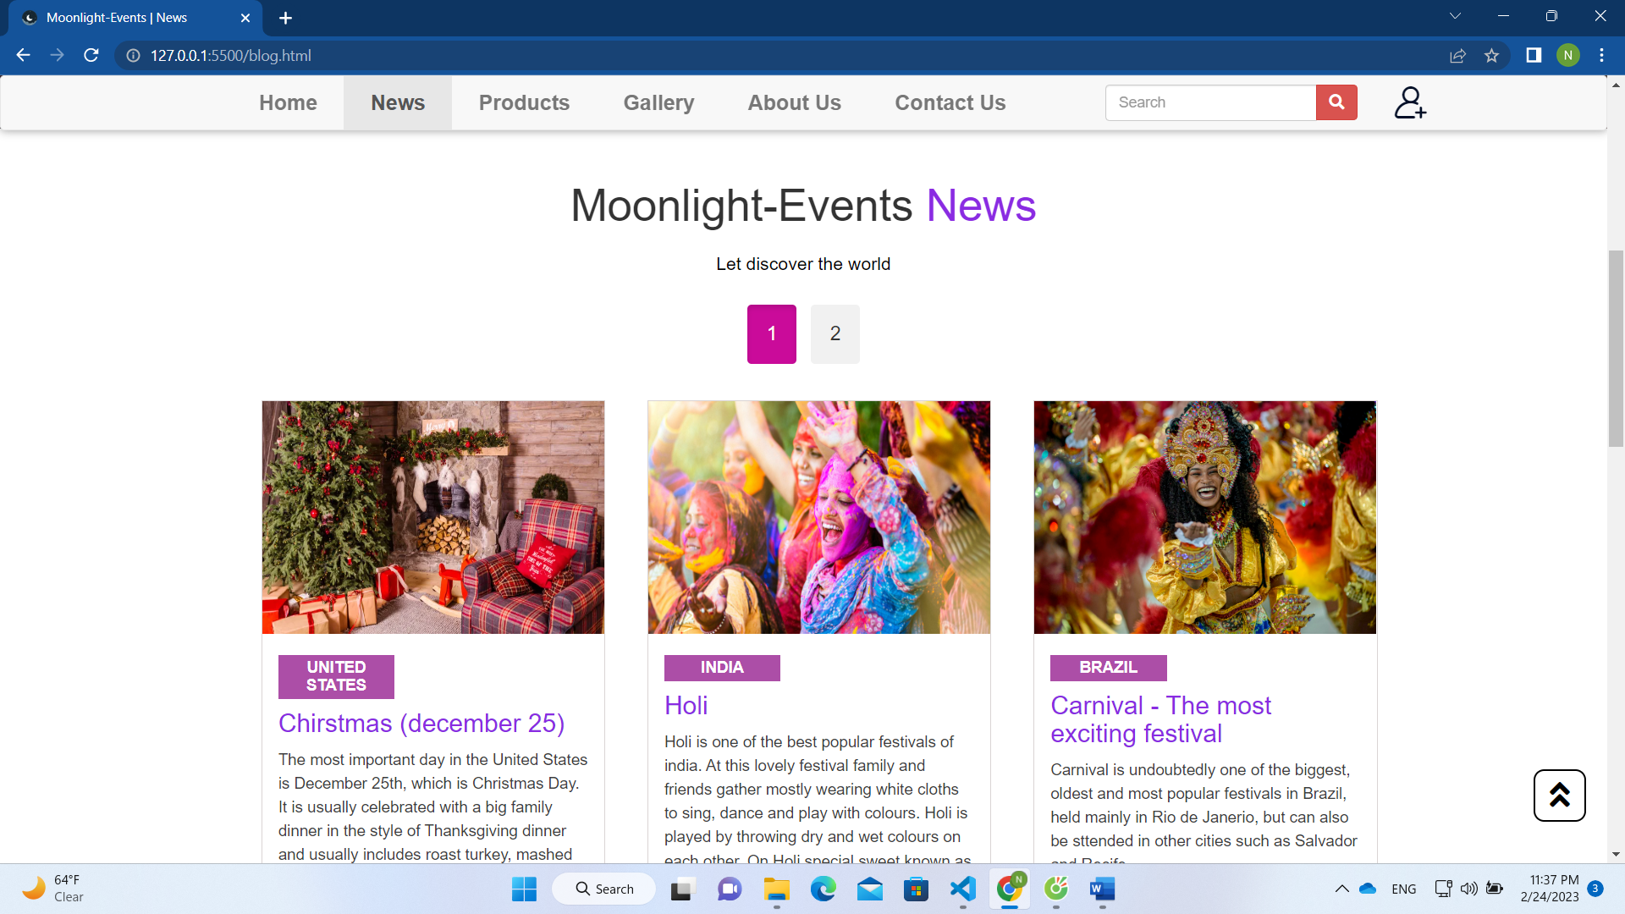

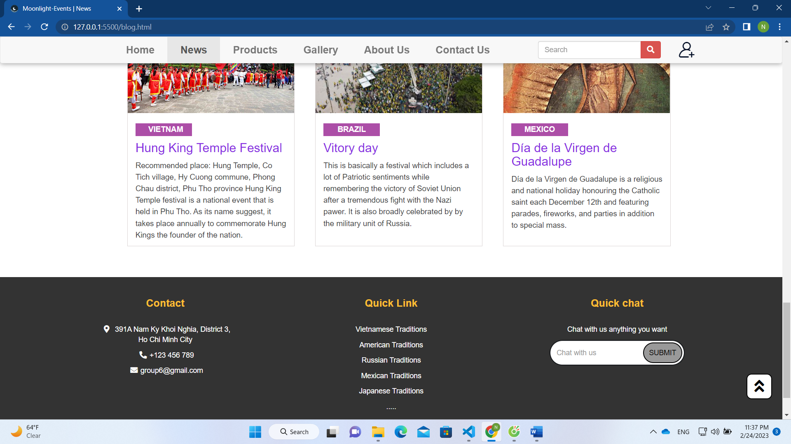

1. **Products**
2. Screen shot

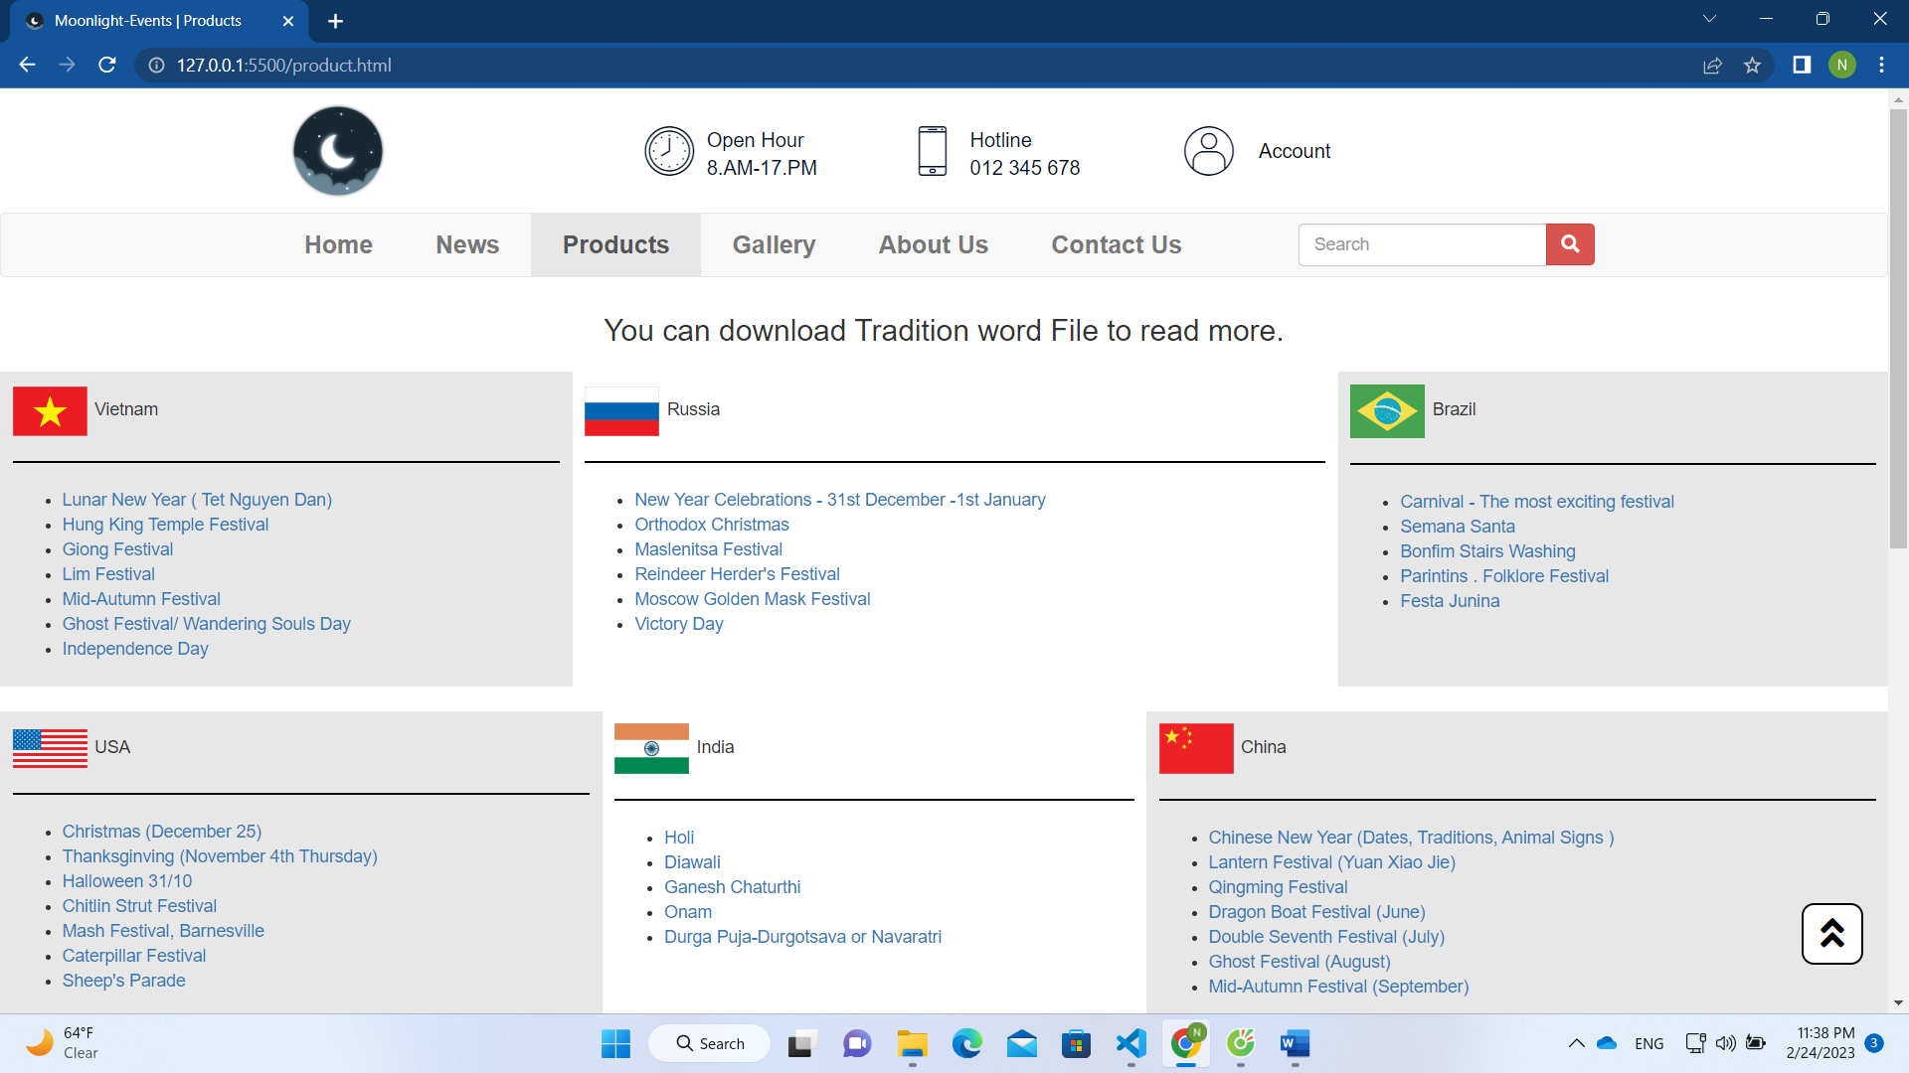

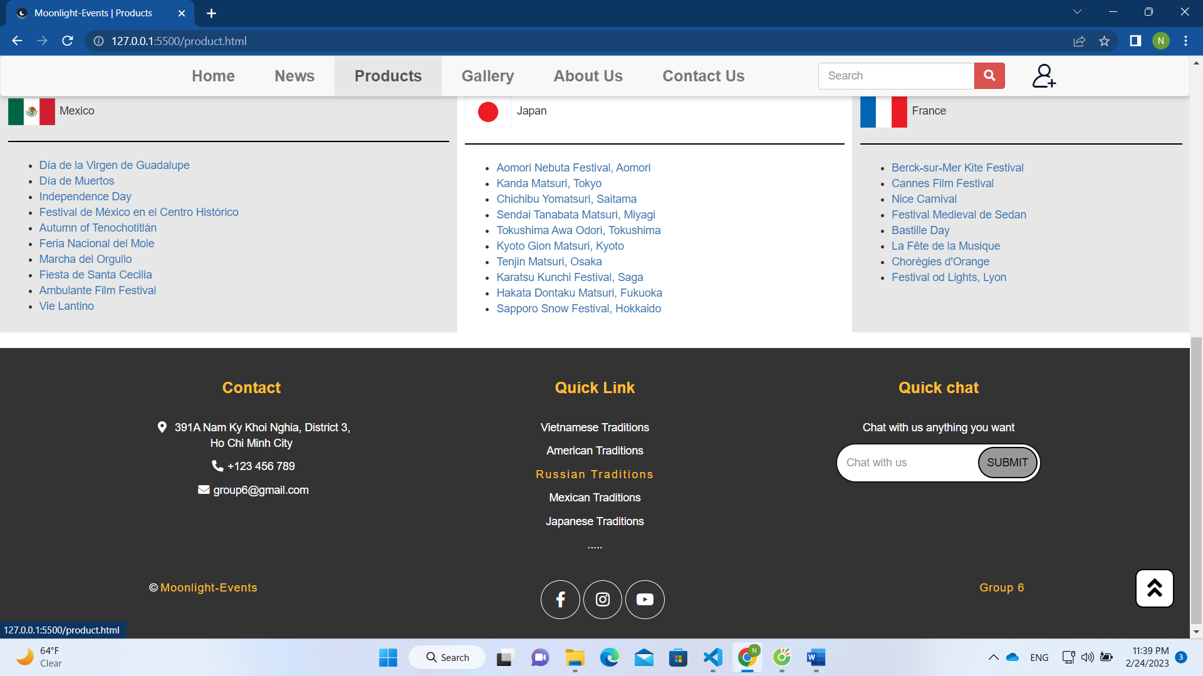

1. **Gallery**
2. Screen shot

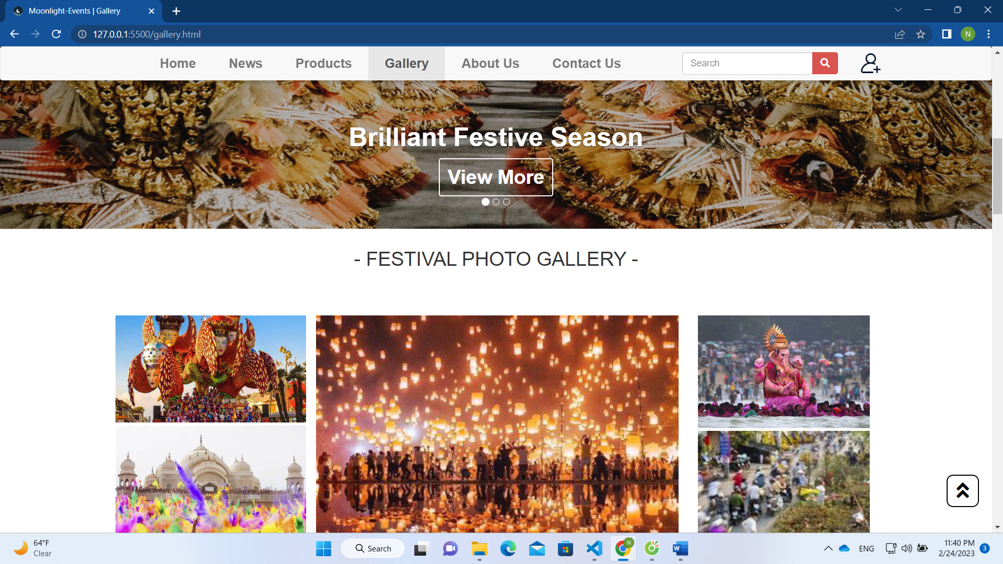

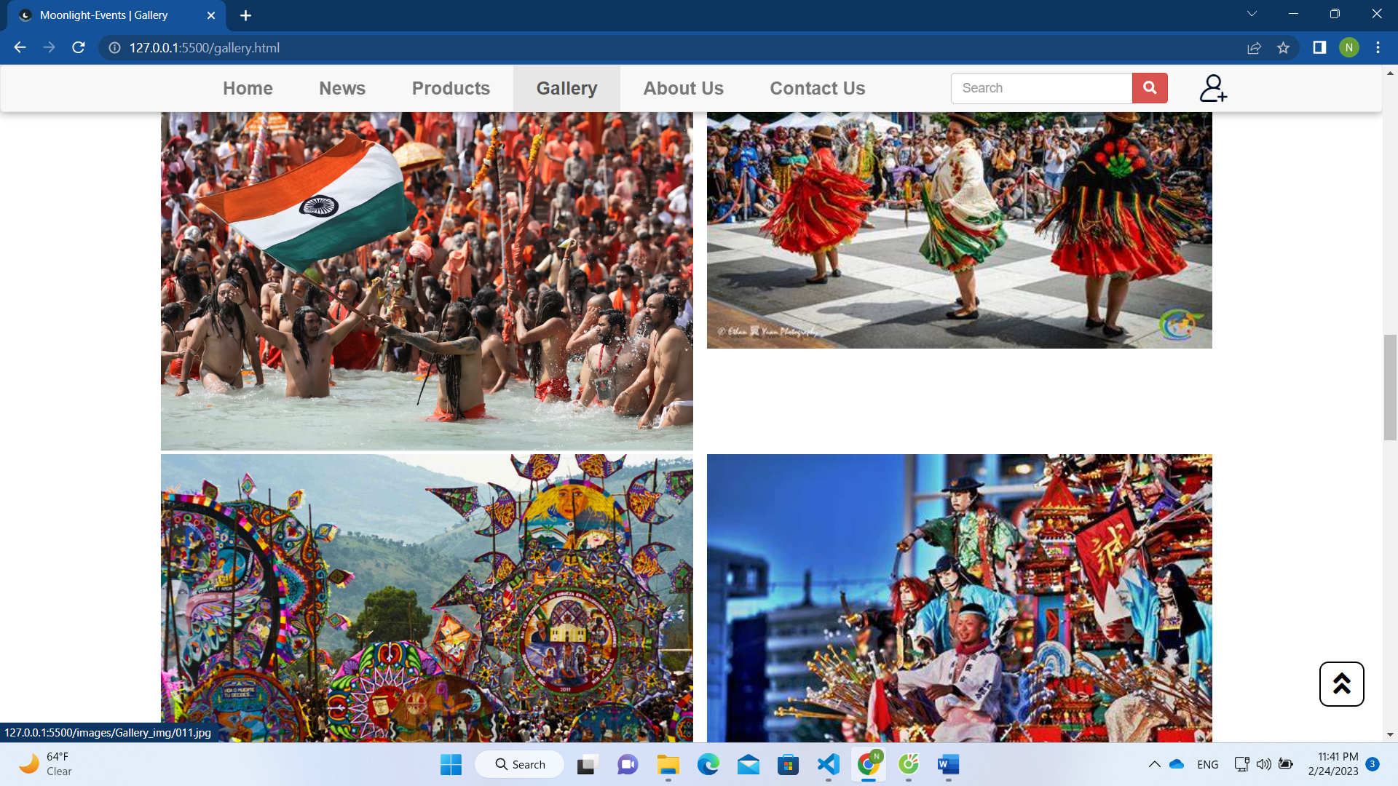

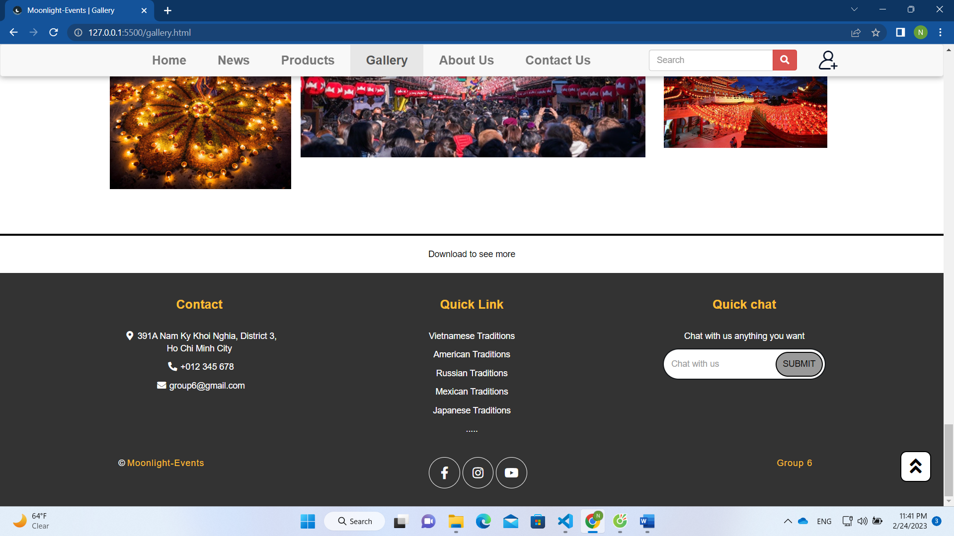

1. **About Us**
2. Screen shot

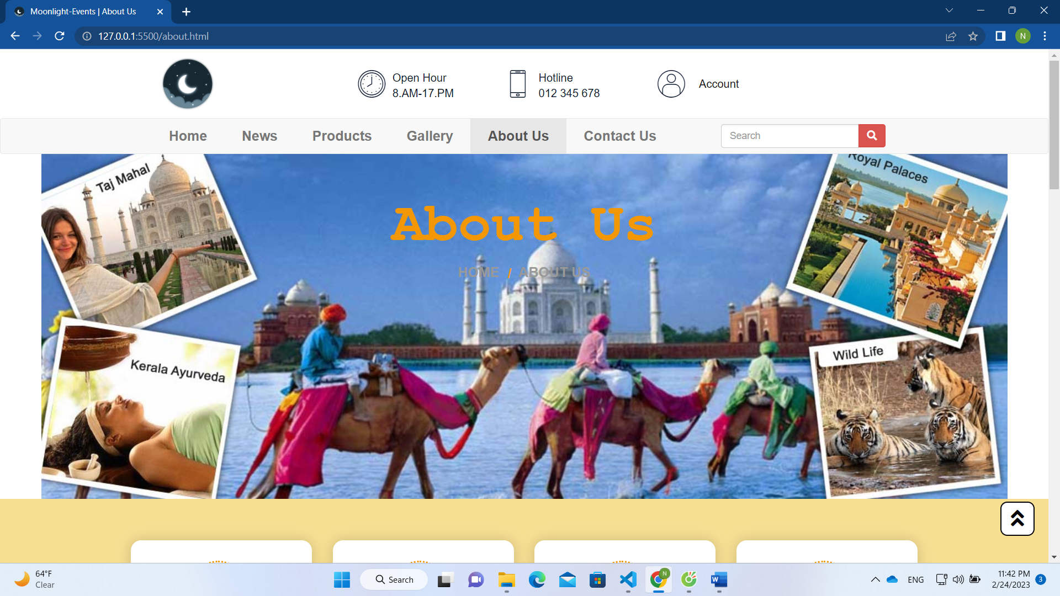

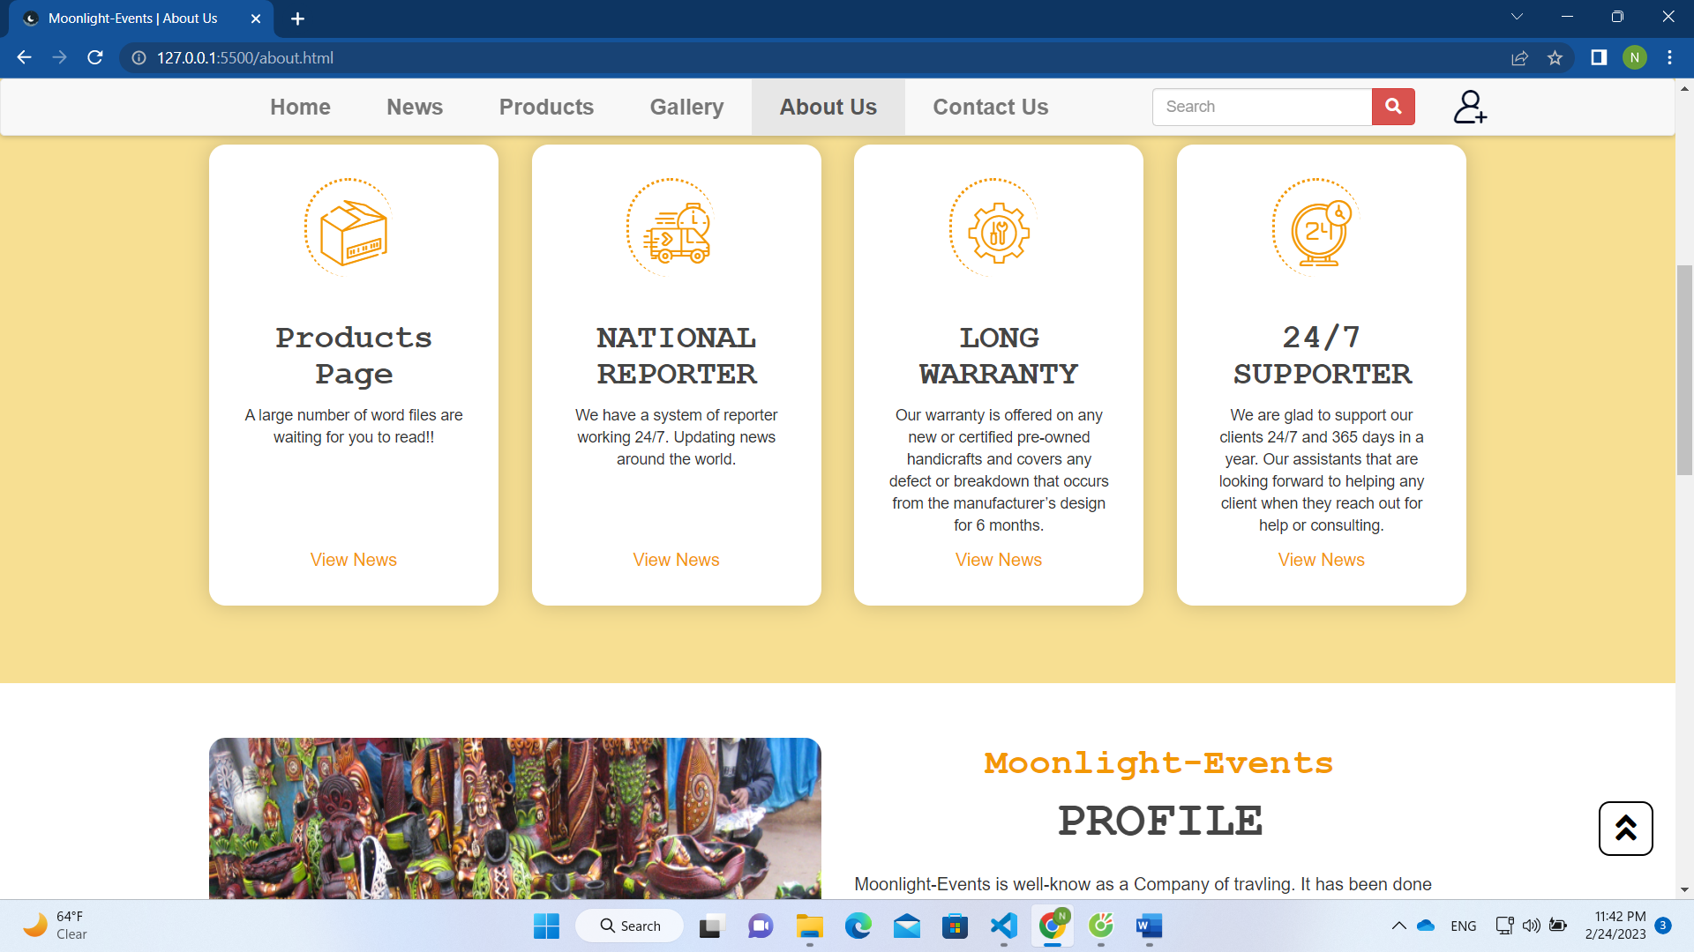

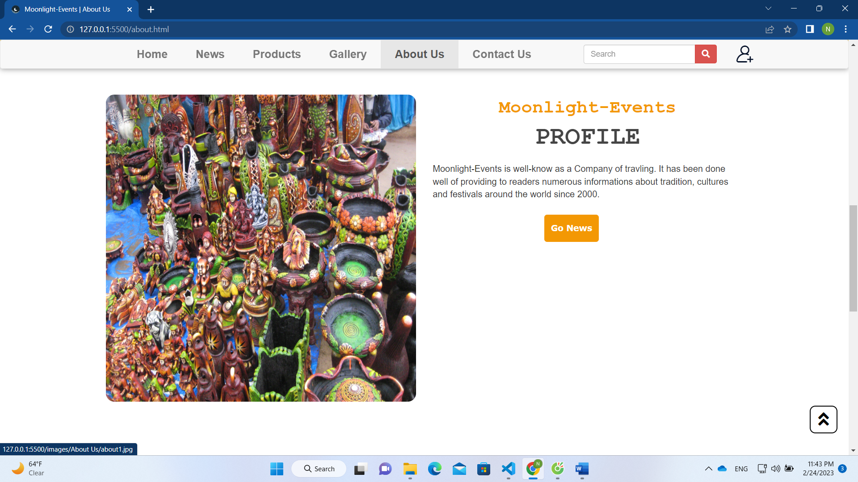

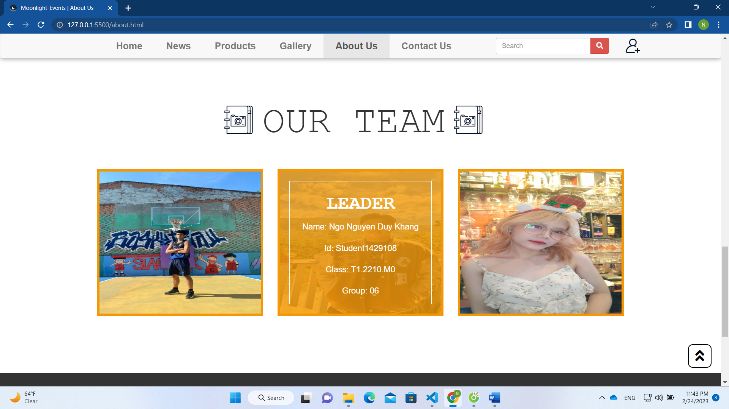

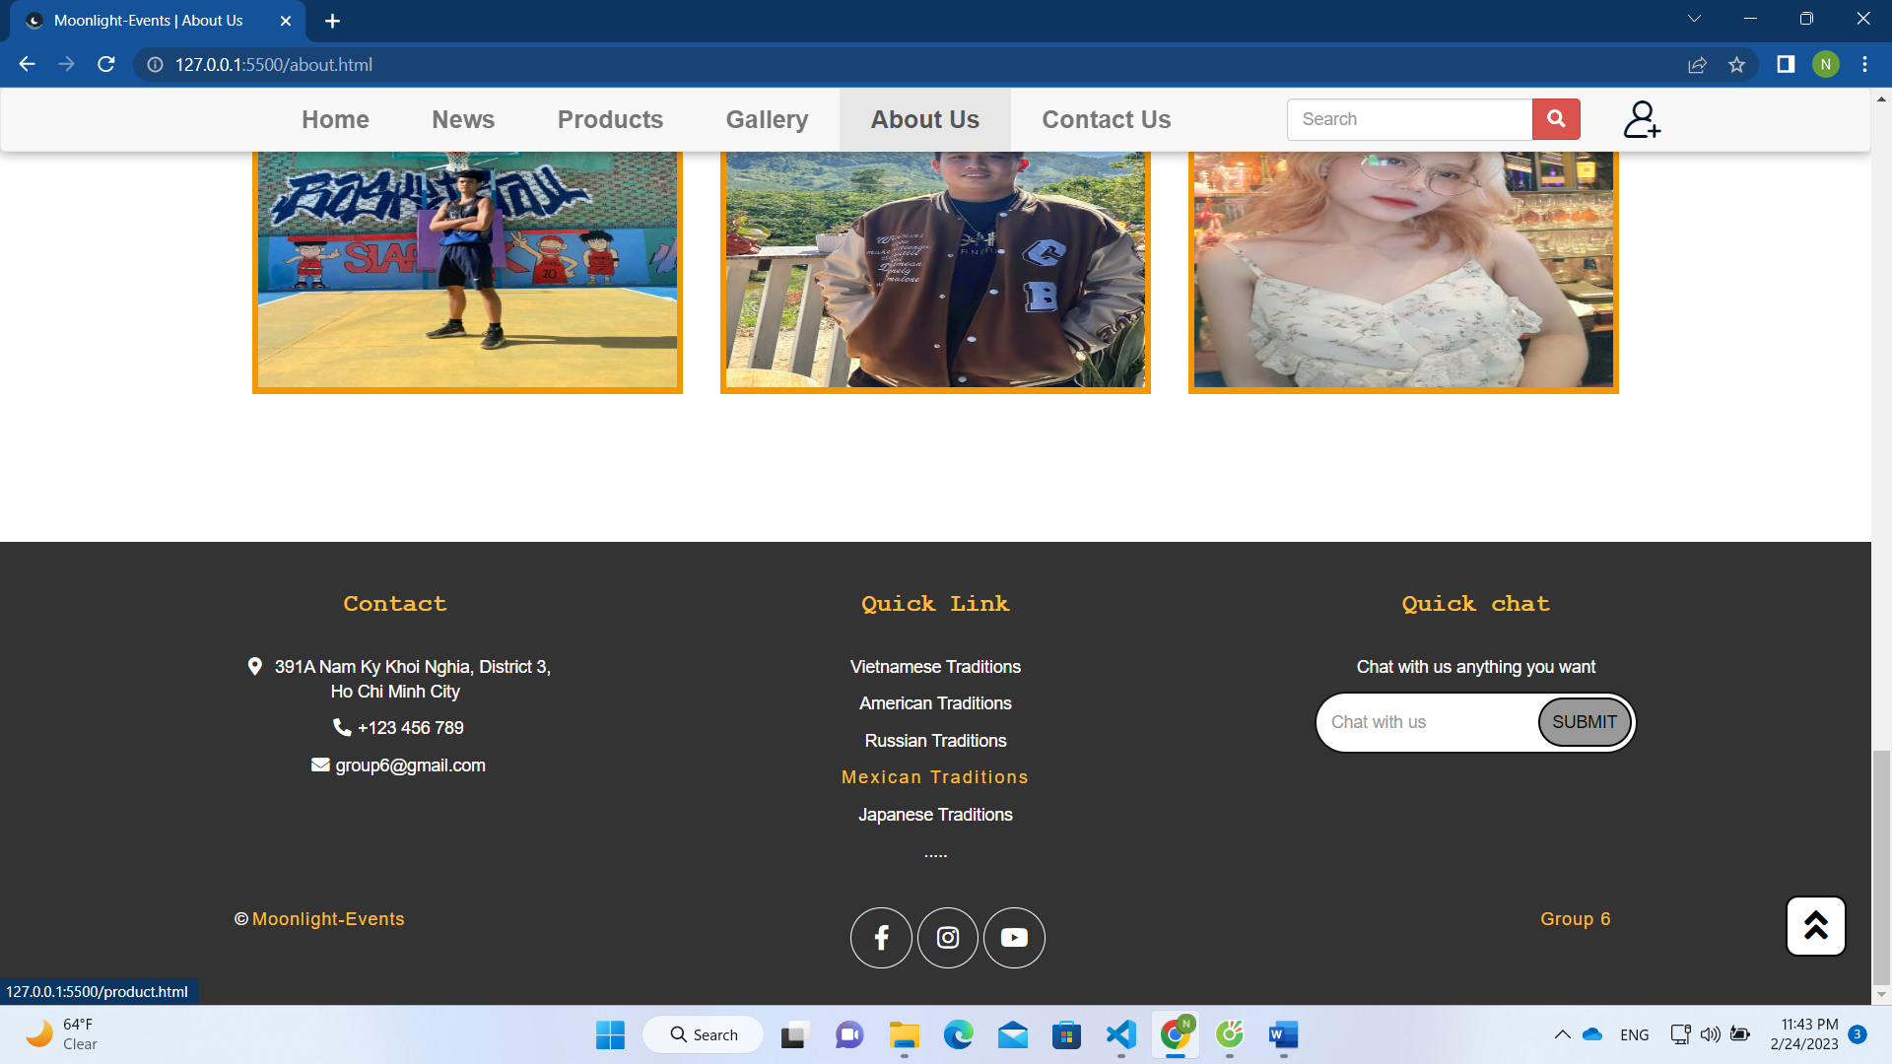

1. **Contact Us**
2. Screen shot

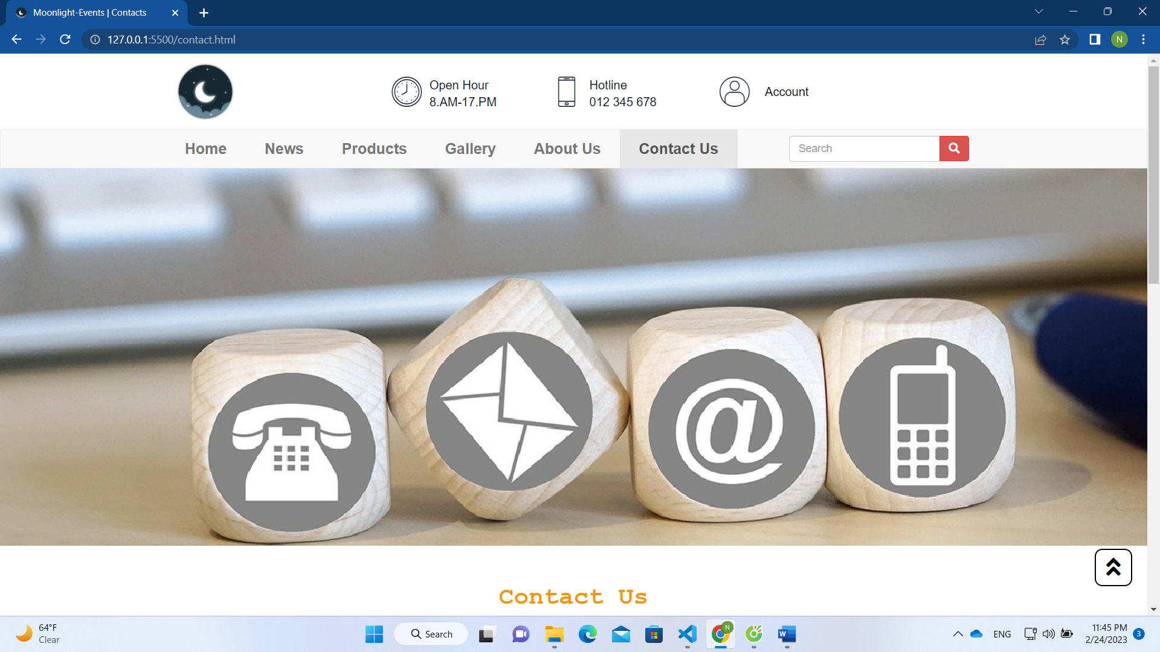

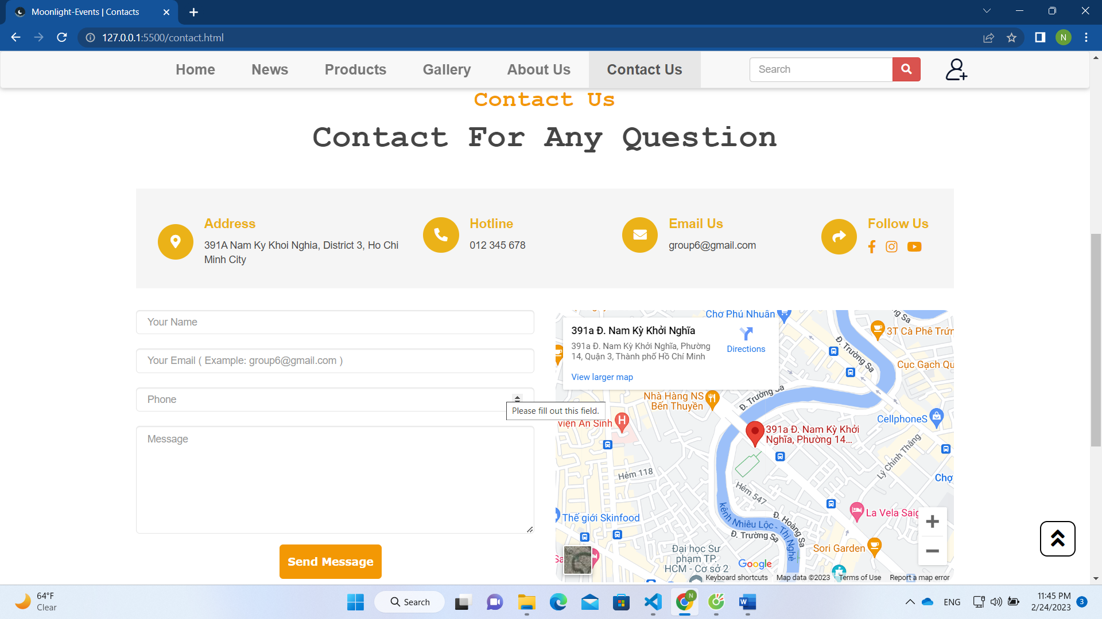

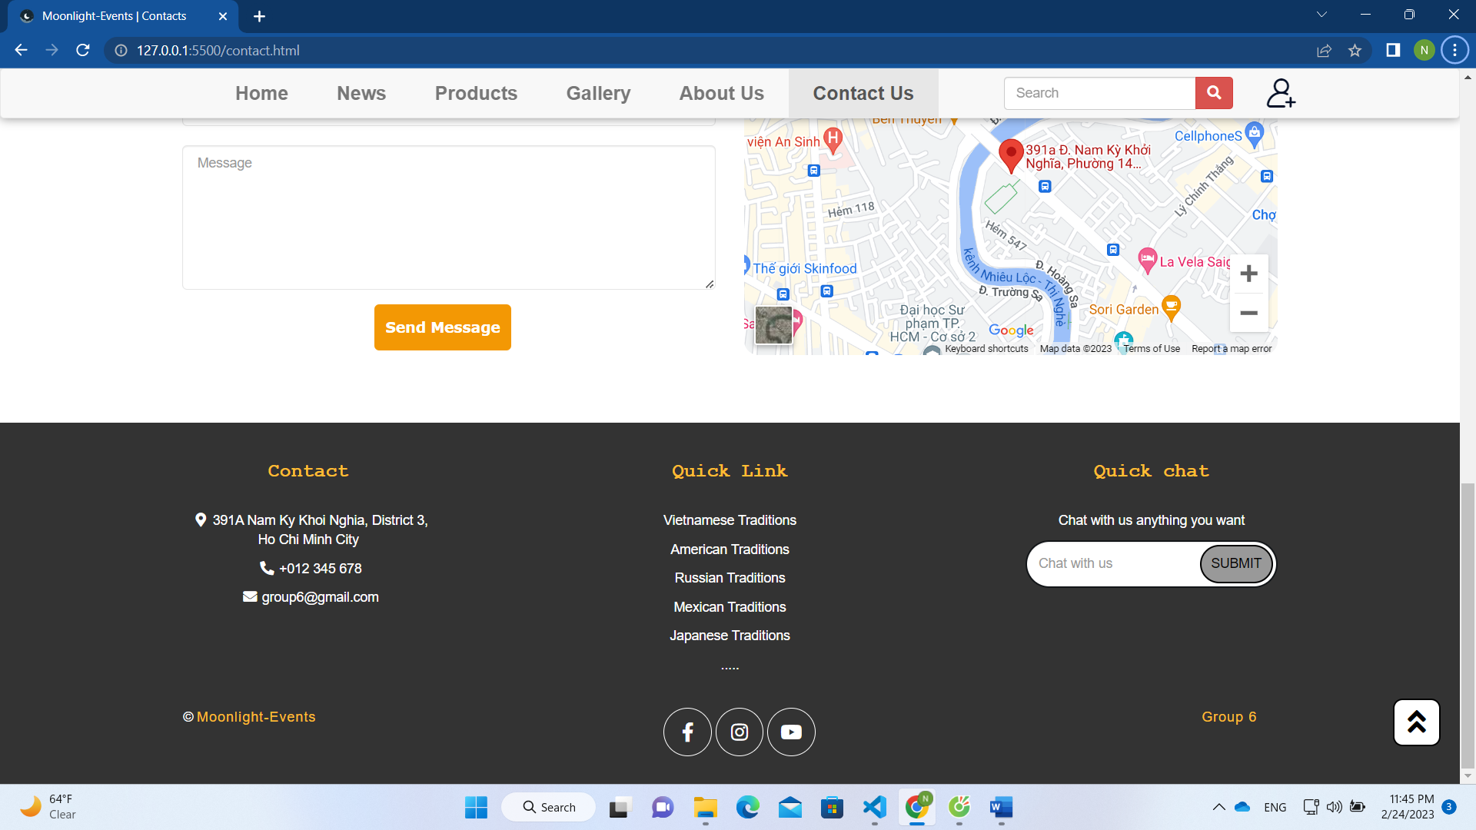

1. **Account**
2. Screen shot

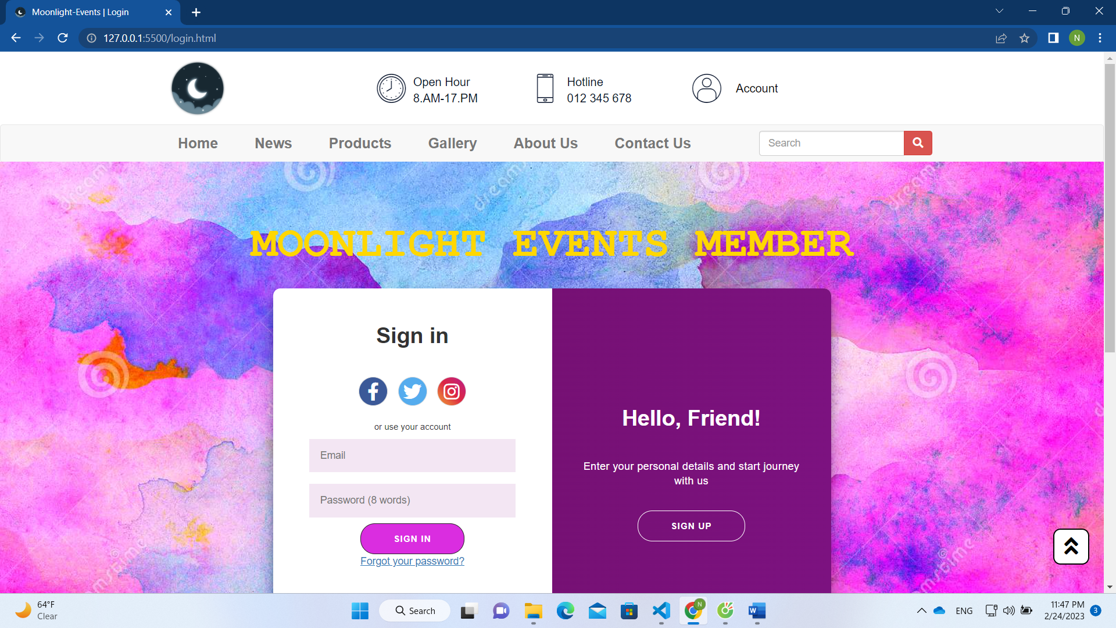

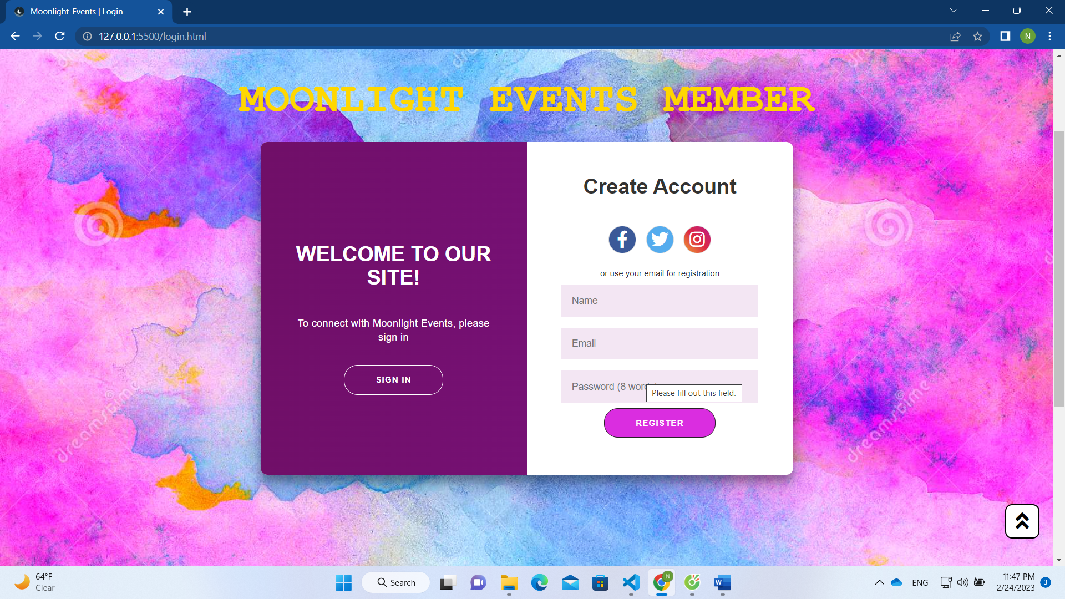

**RESPONSIVE**

The page has responsive feature for small screen device such as smart phone, tablet, etc.

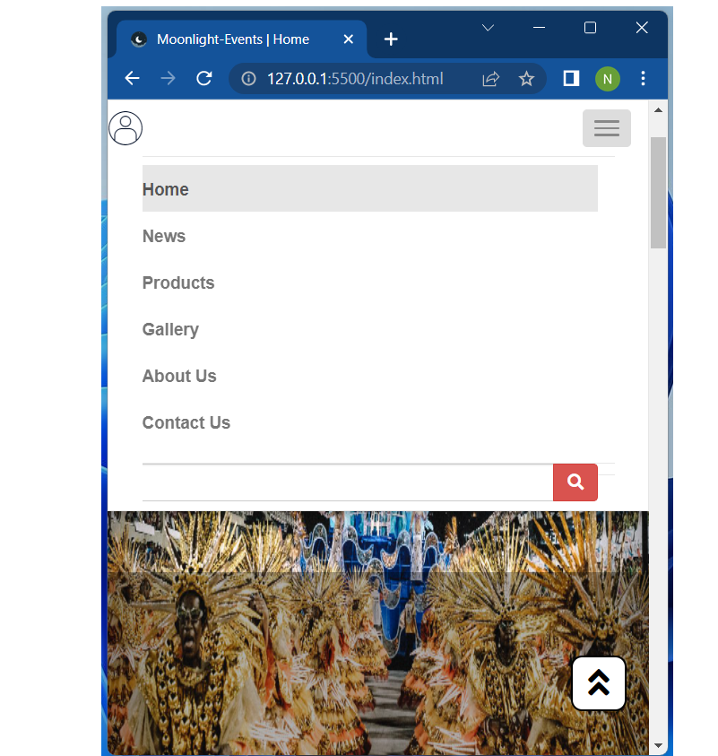

**JAVASCRIPT DESCRIPTION**

1. **Home Javascript**
2. Screen shot

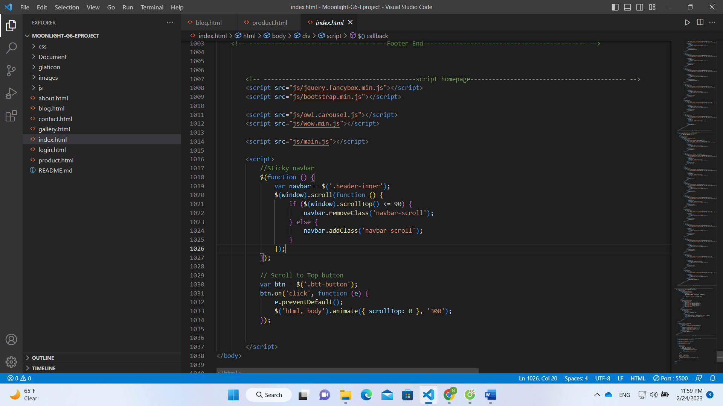

1. **Optional Javascript**
2. Screen shot

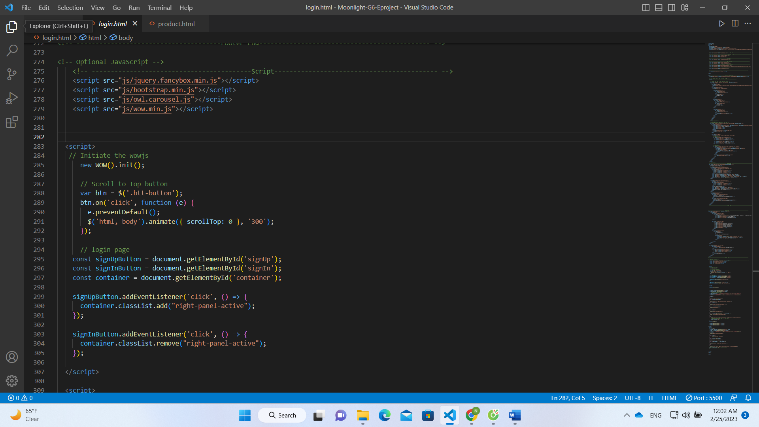

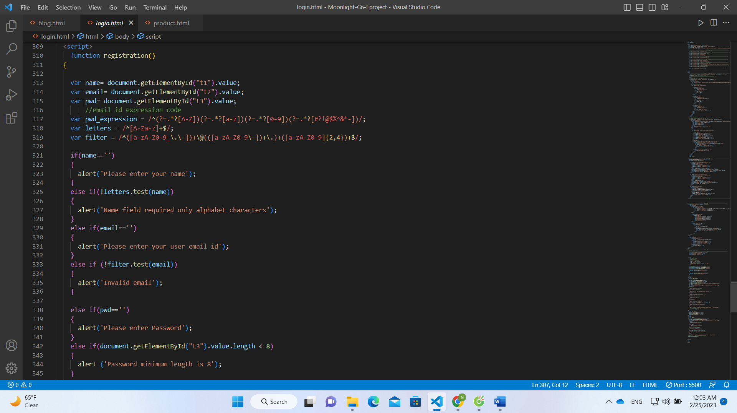

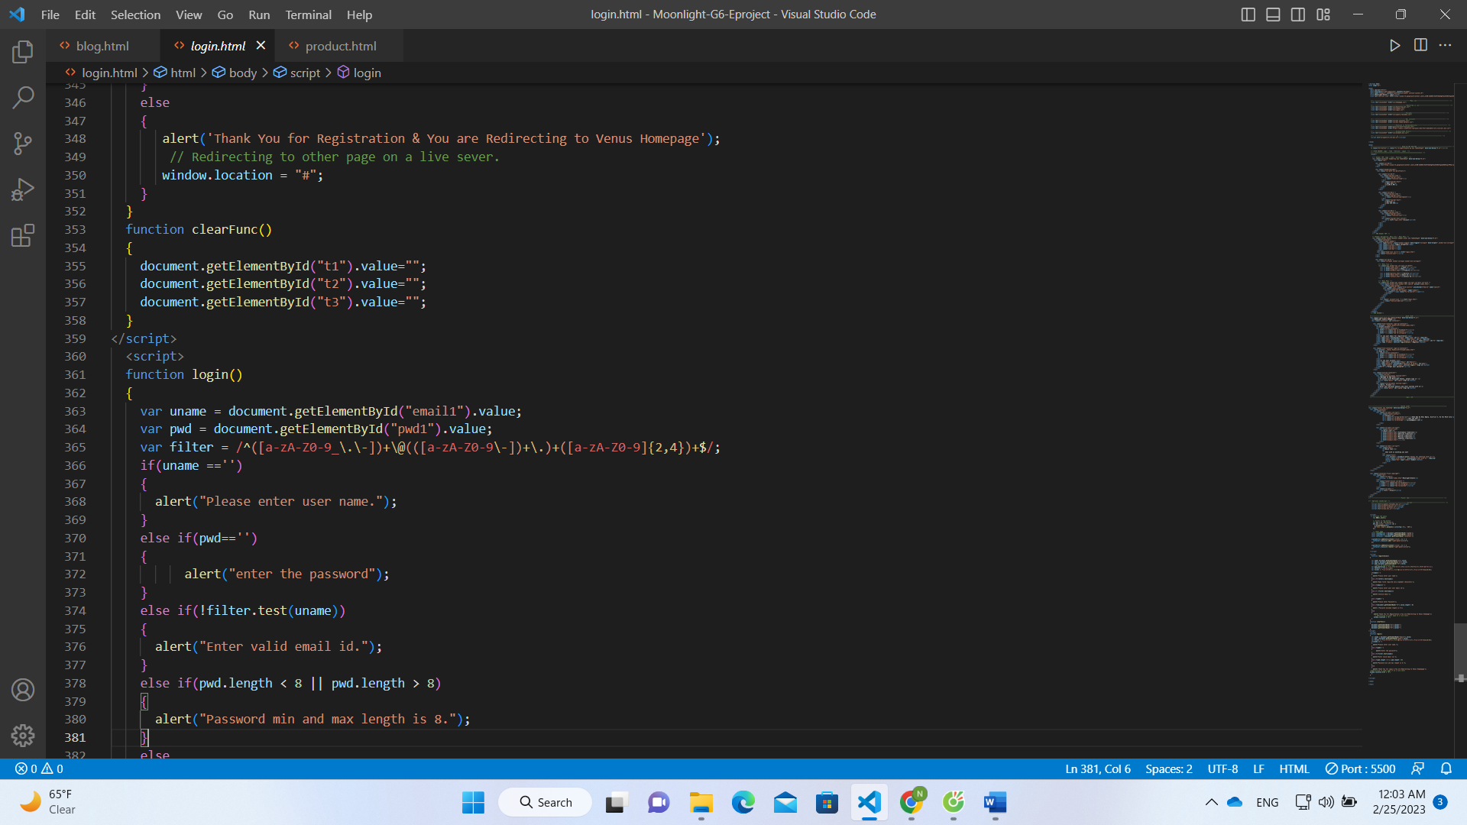

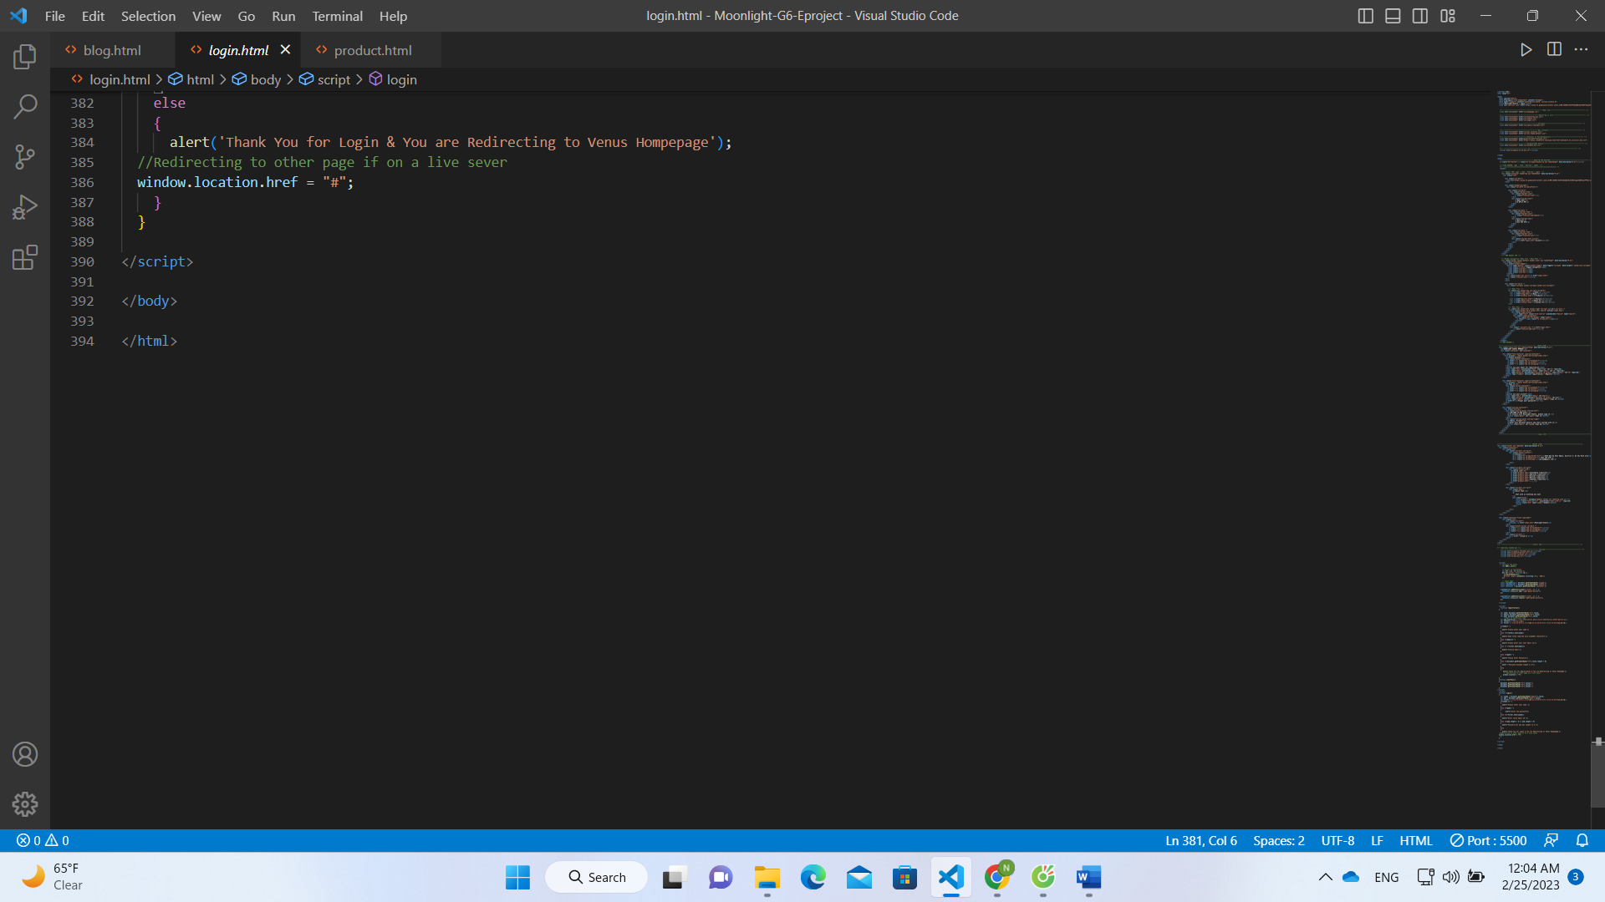

# TASK SHEET REVIEW 3

|  |  |  |  |  |  |  |  |
| --- | --- | --- | --- | --- | --- | --- | --- |
| **Project Ref. No.:**  **eP/Advertisement Portal Management**  **System/01** | | **Project Title:** | **Activity Plan Prepared By:** | **Date of Preparation of Activity Plan:** | | | |
| **Sr.**  **No.** | **Task** | **Actual**  **Start**  **Date** | **Actual Days** | **Team**  **Mate Names** | **Status** |
| 1 | Home | Moonlight  Events | Khang | 07-Feb-23 | 1 | Tien | Completed |
| 2 | News | 08-Feb-23 | 3 | Tien | Completed |
| 4 | FAQ | 13- Feb -21 | 2 | Vy | Completed |
| 5 | About Us | 15- Feb -21 | 2 | Vy | Completed |
| 6 | Contact Us | 17- Feb -21 | 2 | Vy | Completed |
| 7 | Sign In/ Sign Up | 19- Feb -21 | 1 | Khang | Completed |
| 8 | Java Script | 20- Feb -21 | 2 | Tien | Completed |
| 9 | Check and repair | 22- Feb -21 | 1 | Khang | Completed |

|  |  |
| --- | --- |
| **Date:** | |
| Signature of Instructor:  **Ms. Le Mong Thuy** | Signature of Team Leader:  **Ngo Nguyen Duy Khang** |